
By: Lisa Taylor

Beach Towel Garden

FOCUS:

Overview:
(Adapted from K thru 2 Can Do! Math and Economics: Lesson There’s Not Enough Room)

Lesson Description: In this lesson students plan a garden and experience a scarcity of space. Their space is defined by a beach towel. They want to grow a lot of food items for their garden but must make decisions as space is scarce. They use enlarged photos of plants to place on the beach towel to help them make their final decisions. Student learning is assessed by questions and a class discussion.

Concepts:
Economics: Scarcity, Opportunity Costs
Mathematics: Nonstandard Measurement, Area, Perimeter

Student Objectives:
The students will:
- Recognize that scarcity of space forces you to make decisions.
- Recognize that the items that are given up are their opportunity cost
- Recognize the opportunity cost of a choice is the value of the best forgone
alternative.
- Use a PACED decision making process to determine what to put in their garden.
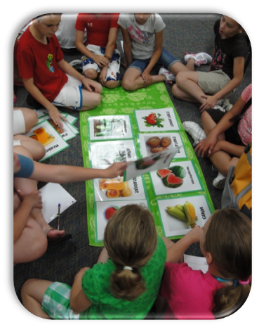
PREPARE:

Time Required:
2 Lessons (30-45 minutes each)

Materials:
- 5 Beach towels
- Vegetable or fruit cards (1 of each per group)
- PACED Decision Making Sheet
- PACED decision making guide for the overhead or interactive board
- Rulers
TEACH:

Procedures:
Day 1:
- Have students brainstorm a list of their favorite vegetables and fruits. Compile a list as the students share their favorites.
- Have students share gardening experiences. Discuss the work, challenges and things they grew.
- Explain that it is time to think about planting fruits and vegetables for the outdoor classroom at school. Explain that there will be five beds for planting. Each bed will be about the size of a beach towel.
- Show a beach towel to students.
- Discuss space limitations given the amount of plants the students want to grow. Explain that scarcity is not enough resources to produce the goods and services wanted.
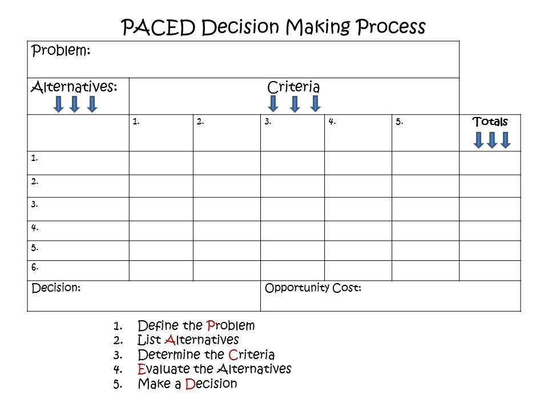
- Explain that due to scarcity, we must make choices. Whenever we have an important decision to make we can use a PACED decision guide.

- Introduce PACED guide using the attached visual on an overhead or
interactive board.
- Spread out the beach towel to show students that the amount of space
is limited. The number of plants we want to plant is great. Therefore, there is a scarcity of space.
- First Step: The first step of the PACED process is to define the Problem. What is the problem in this case? Not enough space to grow everything we want. Write this in the space for the problem on the grid.
- Second Step: The second step is to list the Alternatives. As teacher, model the decision making process, with a Think-Aloud. “My favorite vegetables and fruits are: pineapples, squash, cucumbers, corn, and strawberries.” Add these to the Alternatives list.
- Third Step: The third step is to define the Criteria. Explain that this is what must be considered when making a good decision. For example, do a lot of people like that fruit or veggie? Does it grow in our area? Is it easy to care for? Does everyone in my family like it? Is it hard to care for?
- Fourth Step: The fourth step is to Evaluate the alternatives. This is where you decide if each alternative meets each criterion. This can be done by using + or – or numerical values such as 1 to 5 with 5 being the best. See sample grid.
- Fifth Step: The fifth step is to make a Decision.

Day 2:
- Now divide students into five groups. Assign each group to select five fruits or vegetables to grow. Even though more than five might fit now, as the plants grow the garden will not hold more than five.
- Show the students the beach towels and explain that area is going to be their garden space.
- Have the students measure the sides and calculate the area of their beach towels.
- Have them use the PACED decision making model to decide what plants to grow in their scarce space.

- Groups will then determine their choices for the garden and place the chosen vegetable and fruit cards their group would chose.
- Have students order vegetable and fruit cards in the order of the choices for the garden.
- Students will share how they made their decision and then determine what their opportunity costs were.
- If possible, display student gardens in the hall.

Discussion Questions/ Assessment/Closure
End the lesson with a discussion on scarcity and how it forces you make choices.
- What is scarcity? Limited resources to produce unlimited wants
- Why did we have a scarcity? Limited amount of space
- What was the opportunity cost? The things we could not grow due to space limitations
- Did anyone not get what you wanted?
- What formal process can be used to help everyone make good decisions? PACED decision making grid
- When is a good time to use the PACED process? Anytime
- Who should use the PACED model? Individuals, families, businesses, governments – any unit that needs to make a decision

Extension Activity:
- Pass out vegetable seed packets.
- Have students read the directions and determine the exact space the plant will need to grow.
- Then have students measure out the space on a piece of large grid paper.
- Have students write the vegetables name on the space that will be occupied when the plant is full grown.
- Have students place their plants on a large piece of butcher paper.
- Create a bar graph of the favorite fruits and vegetables of the class.

Standards:
Voluntary National Content Standards in Economics:
Grade Level: 4th

National Content Standards:
Standard 1: Scarcity
Productive resources are limited. Therefore, people can not have all the goods and services they want; as a result, they must choose some things and give up others.
Related concepts: Choice, Consumer Economics, Consumers, Goods, Human Resources, Natural Resources, Opportunity Cost, Producers, Production, Productive Resources, Scarcity, Services, Wants,
Standard 2 : Marginal Cost/Benefit
Effective decision making requires comparing the additional costs of alternatives with the additional benefits. Most choices involve doing a little more or a little less of something: few choices are "all or nothing" decisions.
Related concepts: Decision Making, Profit Motive, Benefit, Costs, Marginal Analysis, Profit, Profit Maximization, Cost/Benefit Analysis

Arkansas Economics Frameworks:
E.7.4.3 Recognize and use the decision making model to make an economic decision: state the problem list the alternatives state the criteria evaluate the criteria make a decision
E.7.4.1 Evaluate the priority of economic wants and consequences of the opportunity costs.

Mathematics Frameworks:
Estimate and measure length, capacity/volume and mass using appropriate customary and metric units Length: 1/2 inch, 1 cm Perimeter: inches, feet, centimeters, meters Area: square feet, square centimeters, square meters
M.13.4.9 Use strategies for finding the perimeter of a rectangle
M.13.4.10 Use strategies for finding the area of a rectangle
DAP.14.4.1 Create a data collection plan after being given a topic and collect, organize, display, describe and interpret simple data using frequency tables or line plots, pictographs and bar graphs

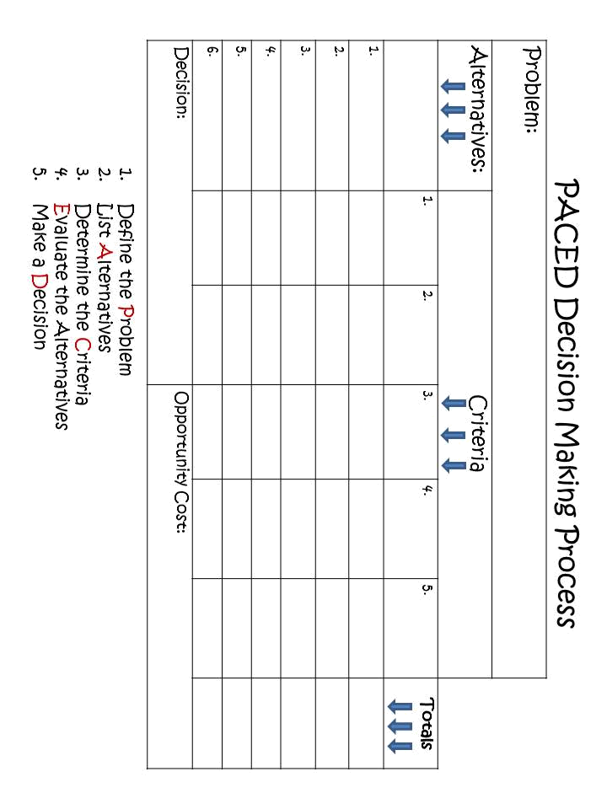
Corn

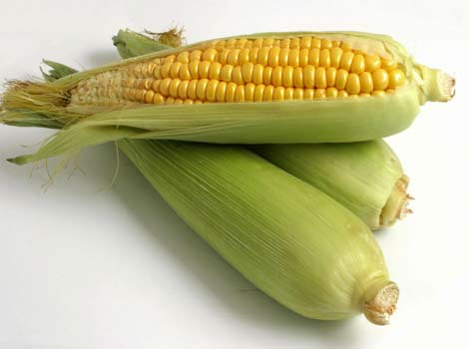
Squash



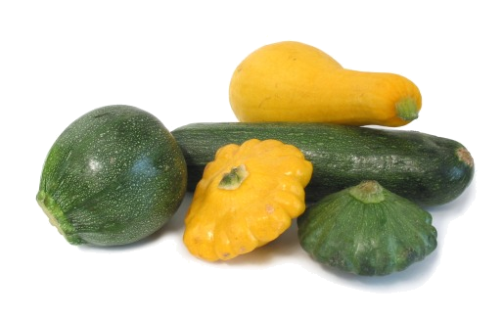

Carrots

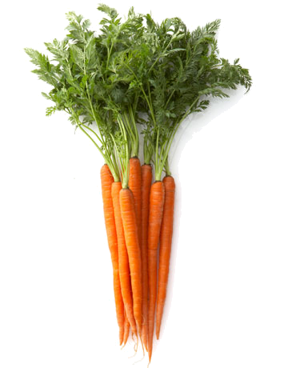

Potatoes

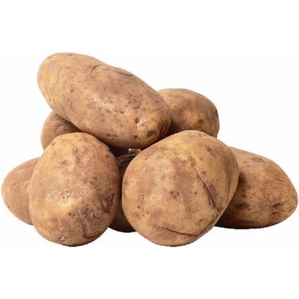

Peppers



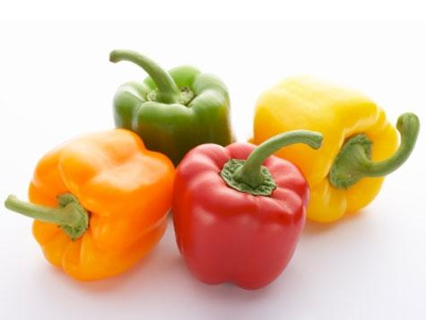

Cucumber



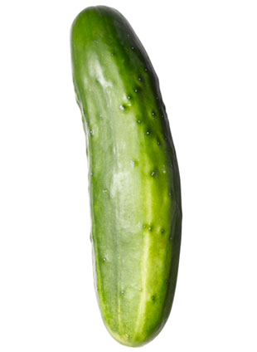

Okra

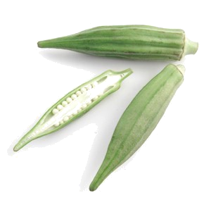

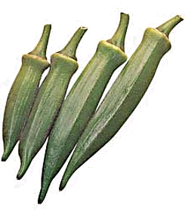

Watermelon

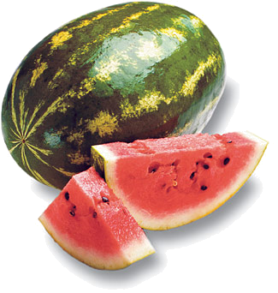

Strawberries

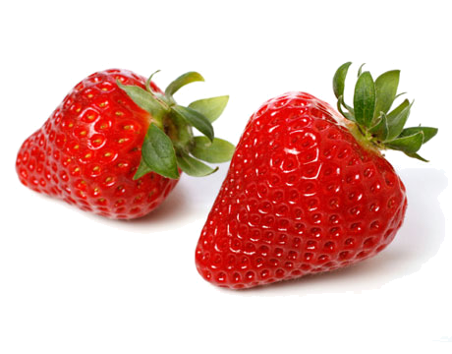

Tomato



