Geography Map Locator:

Places in the Ozark Plateau
Using one color of marker, highlight each of the following.

- Mammoth Springs, Arkansas
Hint: Can be found off of Hwy 63 and in Fulton County

- The Fayetteville, Springdale, Rogers, and Bentonville metropolitan area in Arkansas
Hint: Can be found in Washington and Benton Counties

- Buffalo River – first national river
Hint: Stretches from Newton County to Marion County

- Beaver Lake – recreation and water supply from the White River
Hint: Can be found in Benton and Washington Counties

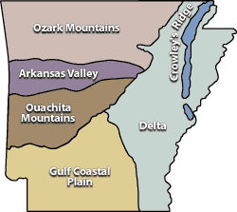
- Eureka Springs – historical Victorian village
Hint: Can be found near Beaver Dam

Places in the Arkansas River Valley
Using a different colored marker, highlight each of the following.

1) Arkansas River - transportation
Hint: Enters near Fort Smith, Arkansas

- Mount Magazine, Arkansas – highest point in Arkansas
Hint: Located in Logan County

- Petit Jean State Park – Winthrop Rockefellers Farm
Hint: Located at the tip of Conway County

- Altus, Arkansas – wine production
Hint: Located in Franklin County

- Fort Smith, Arkansas – gateway to Indian country or wild west
Hint: Located in between Crawford and Sebastian Counties

Places in the Ouachita Mountains
Using a different color of marker, highlight each of the following.

- Hot Springs, Arkansas – spa town and horse racing
Hint: Located in Garland County

- Lake Ouachita - recreation
Hint: Located in Montgomery and Garland Counties

- Hot Springs National Park
Hint: Located in Garland County

- Lake Hamilton
Hint: Near Hot Springs
Places in the Mississippi Alluvial Plain (Delta)
Using a different color of marker, highlight each of the following.

- Arkansas Post National Monument
Hint: Located in Arkansas County

- Toltec Mounds State Park
Hint: Located in Lonoke County near Pulaski County

- West Memphis, Arkansas
Hint: Located in Crittenden County on Arkansas/Tennessee border

- St. Francis River
Hint: Located in St. Francis Cross and Lee Counties
- Helena-West Helena
Hint: Located on the Arkansas/Mississippi border
- St. Francis National Forest
Hint: Located in Lee and Phillips Counties

Crowley’s Ridge
Using a different color of marker, highlight each of the following.

- Jonesboro, Arkansas
Hint: Located in Craighead County

Gulf Coastal Plain
Using a different color of marker, highlight each of the following.

1) Texarkana, Arkansas
Hint: On the Arkansas/Texas border and in Miller County

- Crater of Diamonds State Park
Hint: Located in Pike County

- Murfreesboro, Arkansas
Hint: Located in Pike County

- El Dorado, Arkansas
Hint: Located in Union County

- Hope, Arkansas – home to President Bill Clinton
Hint: Located in Hempstead County

Borders
Highlight the six states bordering the state of Arkansas with a yellow highlighter.

Forests:
Using a marker, outline the three national forests: Ouachita, Ozark and St. Francis

Mountain Ranges:
Using a marker, outline the Ozark and Ouachita mountain ranges.
Geography Summary

The Natural State: Arkansas, known as The Natural State, has 75 counties across six distinct geographical regions: The Ozark Plateau, Arkansas River Valley, Ouachita Mountains, Mississippi Alluvial Plain, Crowley’s Ridge, and the West Gulf Coastal Plain. Due to its natural beauty, it is home to 52 state parks, three national forests, Hot Springs National Park and the Buffalo National River. The geography of Arkansas, as in any state, played a major role in the exploration and development of the state. The rivers, delta, and mountains either facilitated or impeded exploration and development of forts, trading posts, and eventually cities. Rich alluvial plains enticed cotton farmers to begin production resulting in the development of plantations. Pine and hardwood forests facilitated the development of the timber industry and the building of the railroads to move the timber. The discovery of oil in the southern part of the state encouraged the development of companies such as Murphy Oil and the growth of cities such as El Dorado. Rivers were used as transportation arteries. Forts or trading posts became cities. Railroads and roads found the easiest paths to navigate the mountains as they reached out to the areas with products needing to be shipped. New technologies create new opportunities for development as we learn to use them to build roads, dams, or airports. Today, with the Internet, people can choose to live in very remote parts of Arkansas and still work as reporters, artists, or even to run businesses located in faraway places.

Natural Resources: Arkansas’ diverse geographical regions and natural features provide a plethora of outdoor activities in the state leading to the development of tourism. Natural resources affect the development of industries. For example, the recent boom in natural gas drilling along the I-40 corridor or the Arkansas River Valley, due to the Fayetteville Shale Play, is creating the development of businesses, employing many Arkansans, and generating revenues for the state. The top three minerals in Arkansas include petroleum, natural gas or methane, and bromine (a gasoline additive is one of its many uses). At one time, Arkansas provided the majority of the United States’ bauxite which is used to make aluminum. Other natural resources found in Arkansas include timber, some coal, as well as sand and gravel deposits. Arkansas is one of the few states with diamonds. They have not proven to be a significant industry but have been popular with people who dig for diamonds near Murfreesboro. The land in Arkansas is used for farming, mining, forestry, transportation, and recreation.

Rivers and Lakes: Arkansas has 9,000 miles of streams and rivers. Before automobiles were used in the area, the Arkansas River was the main mode of transportation. Beginning in Colorado, the Arkansas River is the longest tributary to the Mississippi-Missouri system (http://www.arvtripeaks.com/). The Arkansas River was discovered by Europeans before the Mississippi, and in 1541 Francisco Vasquez de Coronado crossed it near Dodge City, Kansas. A short time later, Hernando de Soto was on the lower part of the Arkansas before discovering the Mississippi. Other rivers in the state include the Buffalo, the White, Kings, Saline, Red and many more. The White River was dammed, resulting in the formation of five lakes: Beaver, Table Rock, Lake Taneycomo, Bull Shoals and Norfolk before continuing its journey across the Delta and into the Mississippi. The Mississippi River forms most of the eastern boundary of Arkansas. The Ouachita River spills out of scenic Lake Ouachita nestled in the Ouachita National Forest. Many residences and visitors participate in the fishing and canoeing opportunities which spurred the development of industries such as Ranger Boats in Flippin, Arkansas. To take a look at the variety of lakes, rivers, and the activities associated with each, visit the Arkansas Parks and Tourism at http://www.arkansas.com/lakes-rivers/.

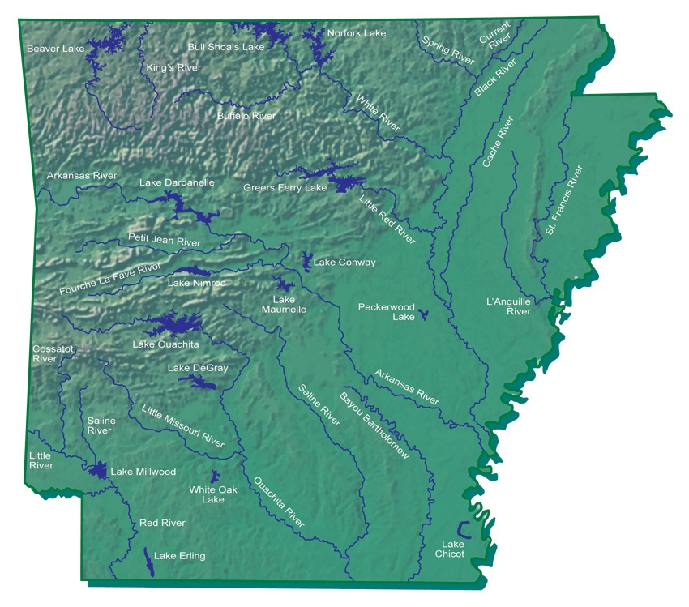

Forests: Arkansas is home to three national forests covering more than 2.9 million acres: Ouachita, Ozark and St. Francis. These provide many camping, hiking, hunting, fishing and four-wheeling activities.

Mountains: Two mountain ranges, the Ozarks and Ouachitas provide rugged hiking and camping opportunities. Each region hosted the development of a spa town: Eureka Springs and Hot Springs respectively.

Location: The six states that border Arkansas are Mississippi, Oklahoma, Texas, Louisiana, Tennessee, and Missouri. Arkansas is considered a southern state.

Climate: Arkansas has a temperate climate with mild winters and warm summers – very warm in the southern part of the state. The Ozarks receive the most annual snowfall, leaving the Ouachita Mountains and the Mississippi Alluvial Plain to receive the most rain. The weather varies across the state and includes tornadoes, drought, snow, ice, and wind.

The Ozark Plateau
The northern and northwestern regions of Arkansas occupy the southern portion of the Ozark Plateau, which extends into southwestern Missouri. It is home to the Boston Mountains. The development and growth of companies such as Wal-Mart, Tyson Foods, and J.B. Hunt have spurred recent growth in Fayetteville, Springdale, Rogers, and Bentonville. There is much fun to be had in the outdoors due to the rivers, lakes and mountains. Several of the counties in this region are home to camping sites with activities such as rock climbing or canoeing. Blanchard Springs Caverns in Stone County and Mammoth Springs provide caving opportunities. For the visitors who spend a long day hiking and do not feel up to camping out, Eureka Springs is a resort community that hosts many special event weekends that pack its bed and breakfast establishments. This Victorian village was developed during the late 1800’s around its healing waters.

The Buffalo River, which was the first nationally protected river, is lined with huge bluffs and creates a floater’s paradise. The White River snakes 720 miles across northern Arkansas, into southern Missouri, and back across the state before it meets the Mississippi in the Delta region.
(http://gorp.away.com/gorp/resource/us_river/ar/whitervr.htm)

The Arkansas River Valley
The Arkansas River Valley cuts diagonally between the Ozark Plateau and the Ouachita Mountains, and can flood frequently, depositing rich soil for farming. The newly discovered Fayetteville Shale Play runs along the Arkansas River and is causing economic development as natural gas is being extracted. The Fayetteville Shale Play is a deposit of gas trapped within a rock formation. Fort Smith is located on the river at the Arkansas-Oklahoma border. It was the last post of civilization before the Wild West and Indian Territory. In the 1800’s it was home of Judge Issac Parker known as the “Hanging Judge” because of the many men sent to the gallows. The new U.S. Marshals Service National Museum is located in Fort Smith. (http://www.historybuff.com/library/refhanging.html and
http://www.legendsofamerica.com/AR-IsaacParker.html )

The Arkansas River Valley hosts a microclimate prime for grape growing, thus wine production. The town of Altus, made famous by the show The Simple Life, was first established by German speaking Catholic settlers who began growing grapes for the purpose of making wine. The Weiderkehr and Post families were the first clans to set up vineyards here. Mt. Magazine, which is the state’s highest point, is also located in this region. Mt. Magazine has become a butterfly Mecca with its variety of flora and fauna serving as host and nectar plants. An annual festival lures people to its newly built lodge. Of the fifty-two state parks in Arkansas, several of them are located in the River Valley, such as Petit Jean, Mount Nebo, and Mount Magazine state park. http://www.mountmagazinestatepark.com/images/pdfs/Mt_Mag_Butrfly_cklst.pdf
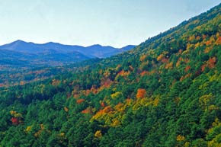

Ouachita Mountains
The Ouachita Mountains are located south of the Arkansas River Valley. This region is made up of some of the oldest mountains in North America. They are smooth and do not look like typical mountains because they have been eroded down by water and weathering. This mountain range is one of two mountain ranges in the U.S. that runs east to west. Two of the minerals contained in the Ouachitas are chert, which was used by Native Americans to make arrowheads and tools, and novaculite, which can be used to make weapons or sharpen knives. This region is home to Hot Springs, the only national park in Arkansas. During the 1800’s it was believed that the hot springs were a therapeutic source for ailments like arthritis. (http://www.nps.gov/hosp/). Oaklawn Park is the state’s only horse racing rack. Visitors can view the finest in thoroughbred horse racing. The lakes of the area provide water sports for many central Arkansans, as well as provide a backdrop for the University of Arkansas’ botanical garden, Garvan Woodland Gardens.

Mississippi Alluvial Plain
The broad and flat Mississippi Alluvial Plain is located in the eastern section of Arkansas. This region, which has some of the best farmland, was formed by alluvial deposits or sediment left by the Mississippi River. Commonly known as the Delta, this region is home of the Grand Prairie Natural Grasslands and is the site of the first territorial capital located at Arkansas Post. The land here was mostly swampy and was cleared to make way for cotton planting. Over the years, people have tried to control the flooding of the Mississippi, the St. Francis, and the White rivers with levees. Flood damage results when the levees fail to hold. Prior to the Civil War, this region was dominated by cotton plantations and other agricultural products. This region now produces crops such as soybeans, rice, cotton, and corn. Helena is home to several blues festivals including the International Blues and the Heritage Festival, formerly known as the King Biscuit Blues Festival and the Delta Blues Cultural Center.

Crowley’s Ridge
Crowley’s Ridge is named for Benjamin Crowley, the first settler to reach the area around 1820. The ridge provided faster and safer travel than the surrounding swamp lands. Crowley’s Ridge is an unusual geological formation that rises up from 250 feet to 400 feet above the Delta region in a 150 mile line from southeastern Missouri to the Mississippi River near Helena, Arkansas. The Ohio River used to flow down one side and the Mississippi River flowed down the other, the water from these two rivers washed away the soil of the river valleys but left a ridge, which now provides protection from the floods that can put the Delta under water. Most of the major cities of the region lie along the ridge which is composed of windblown soil called loess. The flora and fauna of the ridge, including the St. Francis National Forest, are more closely related to the Tennessee hills than the Ozark Mountains to the west. Jonesboro, the largest city on the ridge, is home to Arkansas State University. Jonesboro can also boast of being the hometown of the first woman to be elected to the United States Senate, Hattie Caraway. http://www.arkansas.com/things-to-do/scenic-drives/crowleys-ridge.asp

West Gulf Coastal Plain
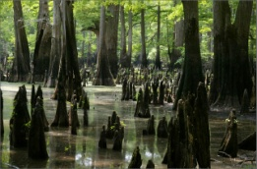
The Ouachita, Saline, and Red Rivers flow through the southernmost part of the state, the West Gulf Coastal Plain. This Arkansas region is located in the southeast and south central part of the state, and it borders Louisiana and Texas. This region has natural gas and petroleum deposits as well as pine and hardwood forests. The lumber industry boomed when the railroads extended to this region, and lumber mill towns, such as Crossett, were created. At one time, the Gulf of Mexico covered this region. When the ocean waters receded they left behind salt and oil deposits deep in the soil. Arkansas is one of the only diamond producing states. Tourists can mine for these diamonds at the Crater of Diamonds State Park in Murfreesboro. The presence of natural gas and oil deposits has brought wealth to the cities of El Dorado and Smackover. Festivals of the West Gulf Coastal Plain include the Purple Hull Pea Festival in Emerson, the Pink Tomato Festival of Warren, as well as the Fordyce Cotton Belt Festival. For tourists who want to check out the hunting in the area, duck hunting is very popular in the West Gulf Coastal Plain.
http://www.arkansassouth.com/

Information was taken from the following sources. Use them to learn more about Arkansas:

http://www.netstate.com/states/geography/ar_geography.htm
http://www.encyclopediaofarkansas.net/encyclopedia/entrydetail.aspx?search=1&entryID=390
http://www.arkansasheritage.com/search/queryhit.asp?UserRestriction=arkansas+river
http://www.arkansas.com/attractions/region/region/Delta

