Creating Opportunity:
Lessons on Development and Challenges of Economic Prosperity
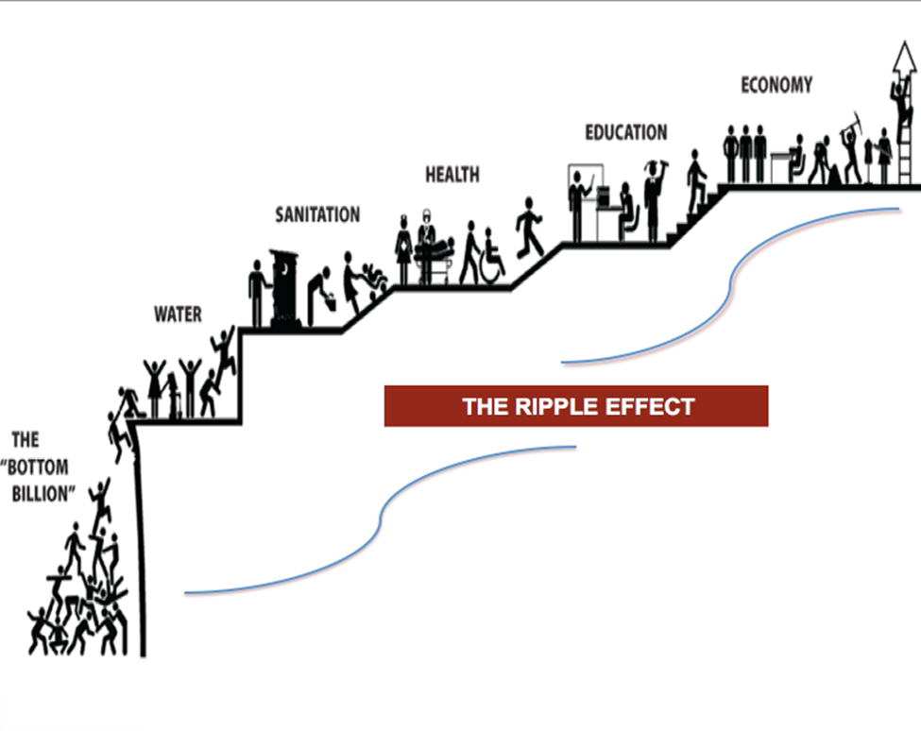

By:
Dr. Rita Littrell
Director, Bessie B. Moore Center for Economic Education
rlittrell@walton.uark.edu

Dr. Rogelio Garcia-Contreras
Director of Social Innovation
rgarciacontreras@walton.uark.edu

Sam M. Walton College of Business
University of Arkansas
Creating Opportunity:
Lessons on Development and Challenges of Economic Prosperity

Table of Contents

Overview
Lesson Summaries
Lesson 1 - Choices: Economic Development Factors
Lesson 2 - Economic Development: Use and Allocation of Resources
Lesson 3 - Production: What, How and For Whom?
Lesson 4 - Alternatives: Achieving Desired Outcome
Glossary
National and State Standards

By: Drs. Rita Littrell & Rogelio Garcia-Contreras
Creating Opportunity:
Lessons on Development and Challenges of Economic Prosperity

Overview
This curriculum is as an introduction to economic development. The essential questions fit well into an economics or business enterprise course. The understandings would frame a service learning course by helping students to look at community issues more holistically. Through these activity based student driven lessons, students begin to view their world and their decisions from a new perspective. They participate in a simulation, debriefing activity, and use Internet based videos and podcasts to learn about the issues and to find information relevant to them and the questions posed. The pedagogical variety reaches a wide variety of learners giving them the opportunity to engage and personalize the learning experience.

In this curriculum, there is not one right answer, but rather a lot of possibilities. The objective is to teach the learners about development possibilities and let them find new ways to improve communities and standards of living one project at a time.

This curriculum serves an avenue to help students become aware of challenges of life for people living below the poverty line. It help students recognize that their decisions as consumers, producers, investors, entrepreneurs and change agents can make a difference. The study begins with the introduction to policy tools used by economic developers. Then students function as governments and make production and allocation decisions using limited resources. A debriefing reveals that there is no ‘correct’ solution but that development successes are community specific. The community could be an inner city neighborhood, a rural town, a province, or a country. Students are introduced to the United Nations 2015 Millennium Development Goals and the 2030 Sustainable Development Goals. In the end, students learn about social enterprise models where people who want to make a difference use their entrepreneurial skills to identify ways to organize resources to improve the lives of people. Social entrepreneurship is a growing interest of the millennials and the tech generation. Rather than a continuous giving cycle through non-profit organizations that ebbs and wanes with the economic cycles, social enterprise is woven into the fabric of the local community and enables the people to grow and develop and affect change in their local environment.

Economic concepts are introduced and used throughout the curriculum. The discussion and research opportunities challenge students to think comprehensively about different aspects of living in a planet with limited resources. Questions on the allocation of these resources, the wealth that can be created out of these resources, and the way such wealth is distributed among the population becomes the core of the decisions. Students reflect as well on the importance of trade and other factors affecting the global market economy, from technical concepts such as exchange rates to more endemic challenges of the free market, such as poverty, sustainability or inequality.

Lesson Summaries
The curriculum is divided into five lessons which would take seven to ten class periods depending on how in-depth the teacher wishes to take the activities. The student research and reflection is variable. The first three lessons serve as an introduction to economic development. It is recommended to use all three to provide a full introduction to the topic. Extension activities are suggested and can be used to extend the study.

Creating Opportunity:
Lessons on Development and Challenges of Economic Prosperity
- Choices: Economic Development Factors: Students learn about factors that affect economic development and rank them according to what they believe to be the most important. They then share their thoughts by standing by the sign of the factor they ranked as most important. The objective is to learn through discussion that the correct answer is situation specific and that factors often work together.
Essential Question: What is Development? What is the difference between development and economic growth? Is development needed to achieve higher levels of economic prosperity or should economic prosperity come first as a condition for development? What is the relevance and consequences of aid? Does aid have unintended consequences? What is the relevance and consequences of trade? Does trade have unintended consequences?
Recommended Time Frame: 1 day

- Economic Development: Use and Allocation of Resources: In this activity, students work in groups to use their available resources to produce goods and services for their citizens. They discover that resources are scarce and therefore decisions must be made. Their assigned goal is to help their country develop so that everyone can have a better standard of living. Deciding what and how to produce is very challenging. The problem solving, creative thinking and group interaction set the stage for a lot of thinking, learning, discussion and strategizing. Debriefing is crucial to identify and label the concepts experienced from this discovery learning simulation and to connect their class experience with the real world around them.
Essential Question: In your opinion, what is the most important resource of a nation? How should any economic unit utilize its collective resources to benefit its members? What are the kind of challenges you faced while distributing these resources? Is the debate on the distribution of resources an economic or a political debate? Is it a moral debate? In a world of limited resources and uneven distribution, what are the alternatives a country has to guarantee the basics for its population?
Recommended Time Frame: 1 day

- Production: What, How and For Whom? In the first part of the activity, students reflect on and as a class debrief the trading simulation from the previous day. They share their dilemmas and the resulting production decisions they made about economic development. They relate their decisions to the Millennium Development Goals introduced in the first activity. The group with the highest development level receives a reward for their hard work. In the second part of the activity the students learn about the Sustainable Development Goals and connect their decisions to the new goals established by the United Nations.
Essential Question: What does development mean? Which of the factors of development do you consider to be essential and why? How can we measure development? In your opinion, can development exist without any or some of the factors discussed in class? Is it expensive to guarantee these factors of development for the population? If not all the factors can be provided, which ones would you prioritize and why?
Recommended Time Frame: 3-4 days

- Alternatives: Achieving Desired Outcomes In the activity, students work in groups to research and think deeply about the distribution of limited productive resources. What are rights of humanity? If clean water is a right, then do we channel resources to provide it? And if we do provide clean water, what is the opportunity cost. After researching issues such as population, education, hunger, potable water, access to credit, health care and infrastructure, students will have a Socratic discussion about the benefits of these policies and the challenges of providing them. They will do a costs/benefits analysis of providing water or health care. Again, there is no correct or best answer. The use of these tools are situation specific and are often dependent on the details and unintended consequences of policies.
Essential Question: What is development? What constitutes economic prosperity? How can we define human security? What is the role of the state in providing a solution to the challenges posted by our economic model?
Recommended Time Frame: 2 days

- Social Enterprise: Making a Difference: Students learn about entrepreneurs who are motivated by making a difference. They identify social problems and organize enterprises to address these societal or economic needs.
Essential Question: What is social enterprise? What motivates people to create them?
Recommended Time Frame: 1 day

- Children’s Stories of Change Agents: Student read children’s book about Nobel Laureates and other true stories of change agents from countries around the world. They create a video, story board, mural or other way means of communicating the story to their classmates. They assign Sustainable Development Goal awards to each book.
Essential Question: What are examples of ways people from around the globe have created social or economic change?
Recommended Time Frame: 3 day

