Adding Links to Images in Gallery Format

- First, you will need insert a module.

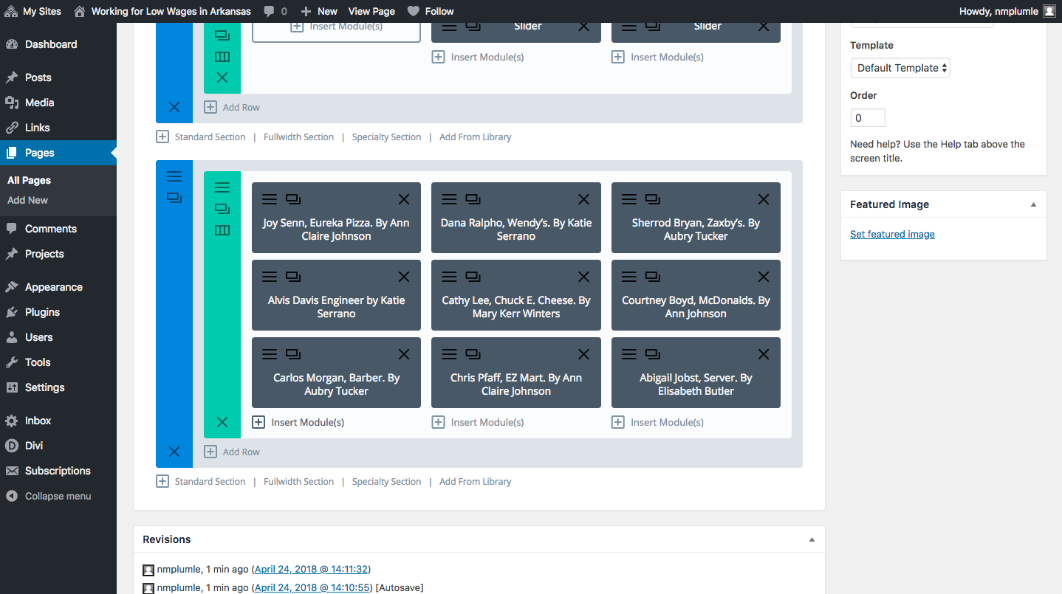

- Click “Image” module.

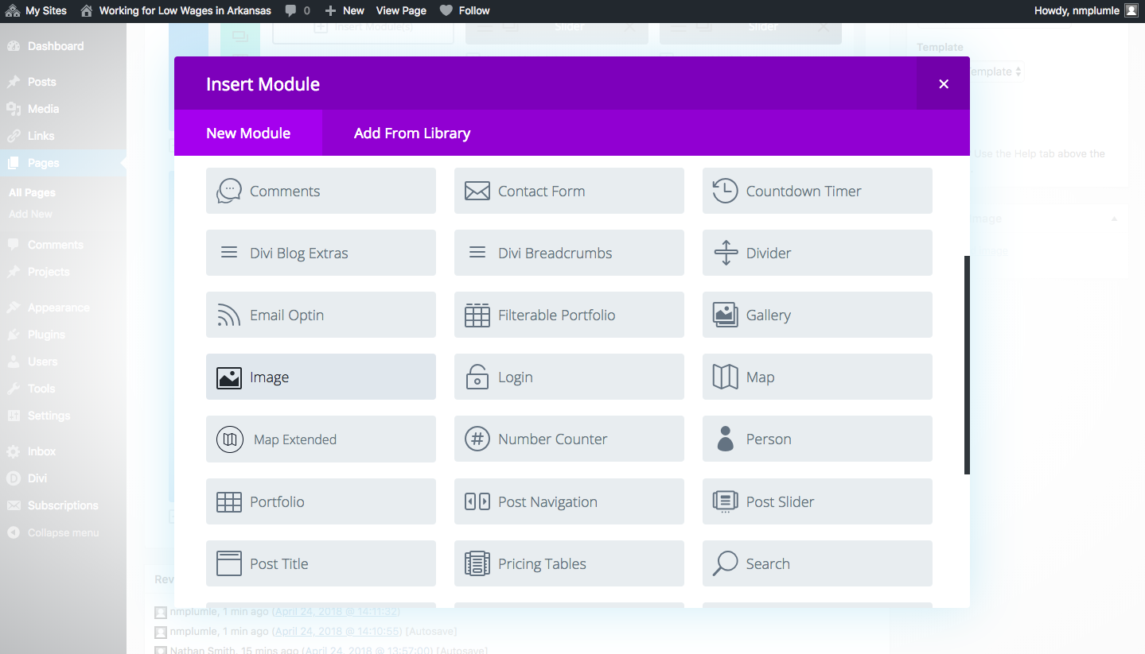

- Here is where you will upload your desired image/the image that goes with your post.

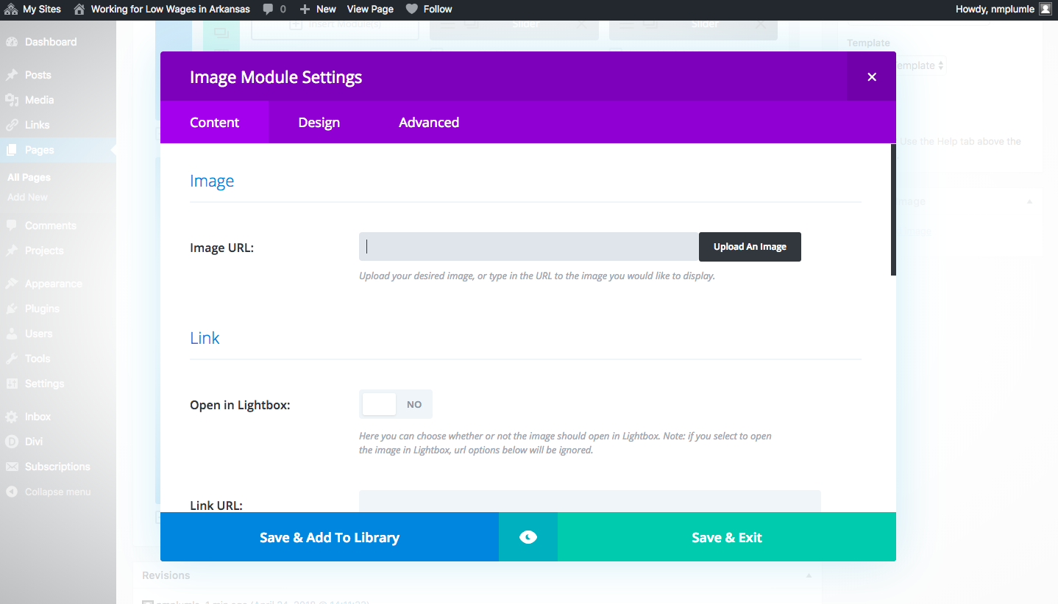

- To link to a post, add the Link URL of your post.

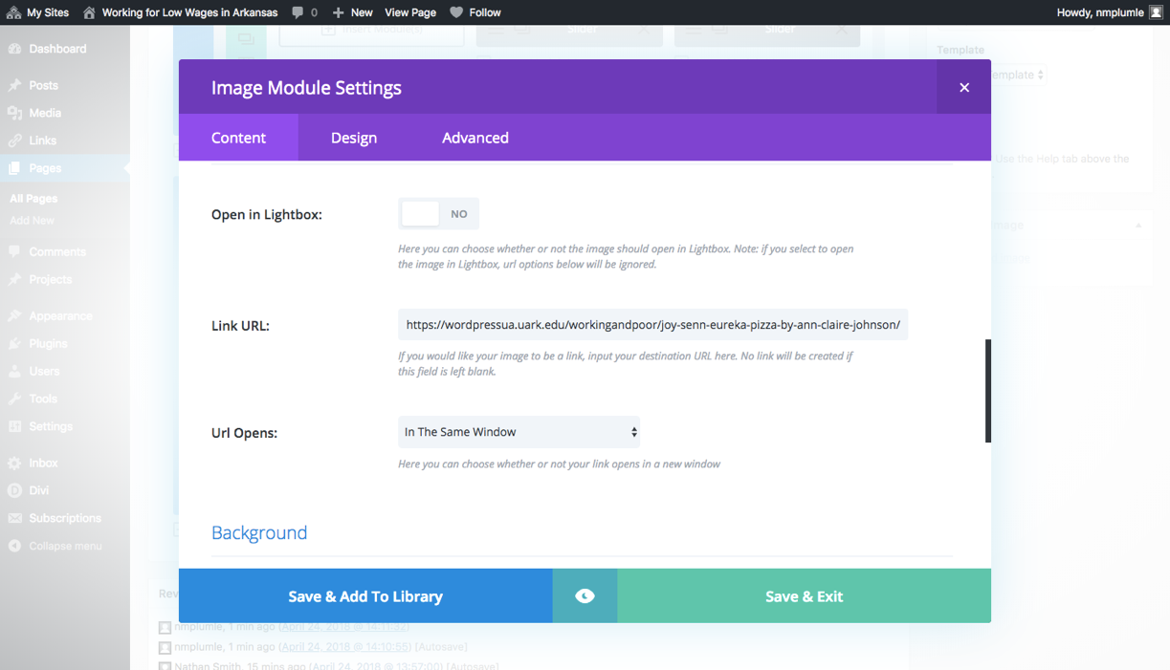

- For an Overlay effect, go to the “Design” tab and toggle the image overlay on. You can also choose the Overlay color.

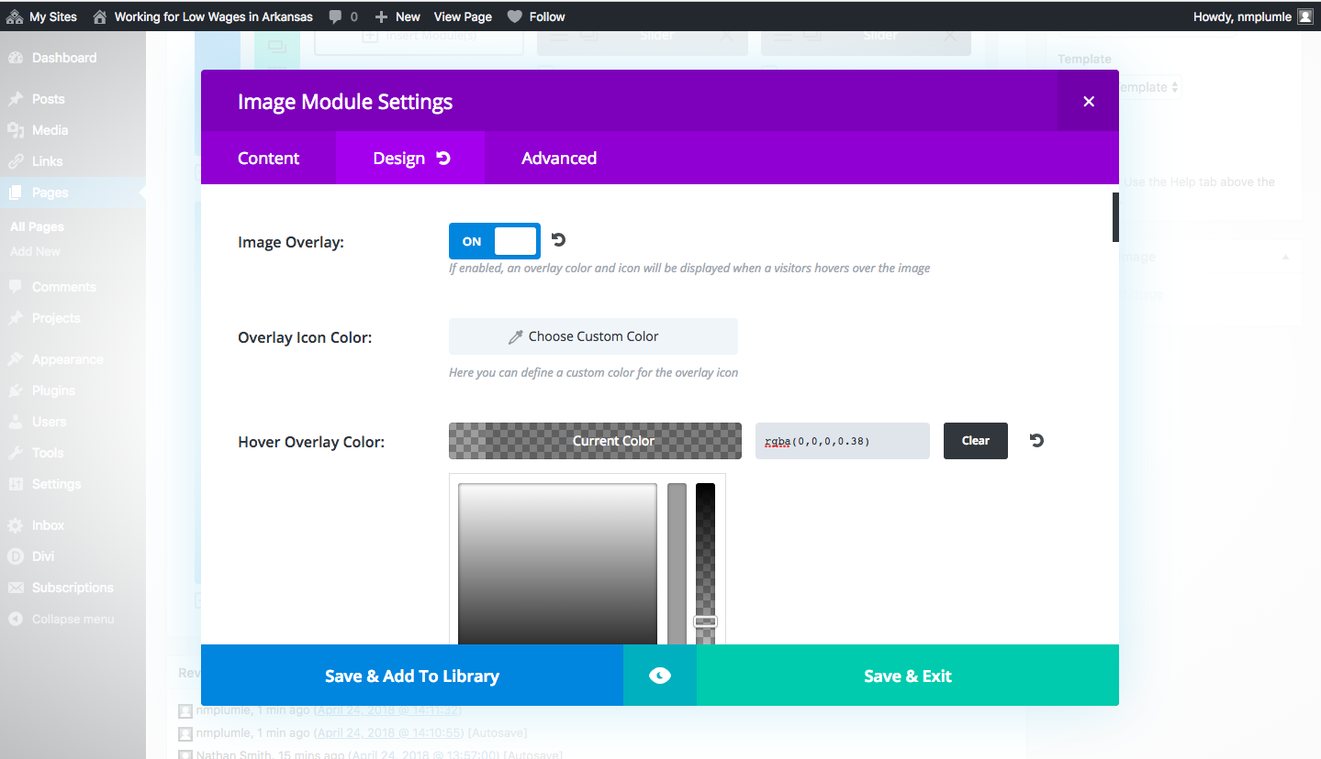

- You can change the overlay image within the module settings, OR you can go to the Visual Builder and see the changes in action.

