Lesson 3 By: Drs. Rita Littrell & Rogelio Garcia-Contreras

Production: What, How and For Whom?

FOCUS:
Overview:
In the first part of the activity, students reflect on and as a class debrief the trading simulation from the previous day. They share their dilemmas and the resulting production decisions they made about economic development. They relate their decisions to the Millennium Development Goals introduced in the first activity. The group with the highest development level receives a reward for their hard work. In the second part of the activity the students learn about the Sustainable Development Goals and connect their production decisions to the new goals established by the United Nations.

Essential Question:
What does development mean? Which of the factors of development do you consider to be essential and why? How can we measure development? In your opinion, can development exist without any or some of the factors discussed in class? Is it expensive to guarantee these factors of development for the population? If not all the factors can be provided, which ones would you prioritize and why?

Objectives:
- Identify the productive resources from the activity
- Discuss what and how they produced the goods and services
- Discover additional ways to provide goods and services for their citizens
- Consider who benefits from development decisions and if they are effective
- Relate their learning experiences to the United Nations Millennium and Sustainable Development Goals

Background Information:
In reflecting on the production activity, students see that there are many ways to build houses. Some are smaller and individual and others house the entire community. They marvel at each group’s ingenuity. They see that some countries have a wider variety of food than others or better education. Clothing styles differ also. They understand that production uses energy, in this case provided by oil. In the simulation, most production decisions are based on resource availability but some decisions are based on the value of the development factor to the citizens. Connections are made to issues in the real world. Students reflect on which countries have more natural resources and which ones have more people? Which countries have capital tools? And what about the energy provided by oil? And water is scarce and necessary. All of these can connect to real issues in the world today. This is the springboard to noticing local or global issues and starting to take action to make a difference.

Time Frame: 3 - 4 class periods - depending on research time allowed.

PREPARE:
Materials:
- One copy of Handout 2.1 Debriefing Questions for each of the four groups. From the Economic Development: Use and Allocation of Resources lesson.
- One copy of Handout 3.1 Economic Development Presentation for each country group.
- One copy of each card on Handout 3.2 Sustainable Development Goals. Cut out cards.
- One copy of Handouts 3.3 Sustainable Development Goals Research for every two students.
- Copies of Handout 3.4 Infographic Rubric for each pair to evaluate each infographic. Pages are designed to be cut in half to save paper. Approximately 125 copies depending on class size.
- Access to the Internet for every two students. This can be via notebooks, laptops or smart phones.

TEACH:
Introduction:
Explain that the class will debrief the activity from the previous day in order to understand the simulation and to make connections to real issues in their community or the world.

Procedures:
Part 1:
- Begin by having each group make their presentation sharing the resources they were given and showing what they produced for their country. Include which Millennium Development Goals were achieved.
- Review the discussion questions that were not discussed previously reflecting on the production outcomes by each countries.
- Discuss ways that students solved problems based on prior knowledge. Label this ability as human capital. Human capital refers to the quality of the labor. Many of the workers used things they had learned in the past to help their country. This knowledge came from previous education.
- Discuss why some goods were neat and had even lines while others were torn or estimated the measurement. The torn ones represent hand produced goods. They are not uniform and perfect.
- What were the challenges for a country with a large population? They had to produce more clothing and food.
- Was the trading fair?
- Were some countries disadvantaged?
- Why was oil required for transportation and clothing production? It represented the need for energy and the source of most of our energy.
- State that if your chose to use your toothpicks to build houses, that you would not have them to build a factory. You gave up the opportunity to build the factory. The choice you gave up is your opportunity cost.
- Give students to opportunity to discuss anything of interest they noticed in the simulation or to ask questions about their observations.
- Ask if they are aware of current or historical occurrences that mirrored their class experience.

Part 2:
- Explain that in the year 2015 the Millennium Development Goals were reviewed with the intention to expand their impact and set more ambitious goals for the year 2030. The new and improved set of goals developed by the United Nations, known as the Sustainable Development Goals, are listed below and in Handout 3.2. These goals are designed to end poverty, protect the planet, and ensure prosperity for all. For more information:
http://www.un.org/sustainabledevelopment/sustainable-development-goals/#prettyPhoto
Sustainable Development Goals
  - No poverty
  - Zero hunger
  - Good health and well-being
  - Quality education
  - Gender equality
  - Clean water and sanitation
  - Affordable and clean energy
  - Decent work and economic growth
  - Industry, innovation, infrastructure
  - Reduced inequalities
  - Sustainable cities and communities
  - Responsible consumption, production
  - Climate action
  - Life below water
  - Life on land
  - Peace, justice and strong institutions
  - Partnerships for the goals
- Group students into pairs. If you class does not have 16 pairs, use as many of the Sustainable Development Goals as you have student pairs.
- Have students research one of the Sustainable Development Goals. The research guidelines are provided on Handout 3.3. These sources will help them to learn about their SDG.
- Allow one to two class periods for the research. Some of the research can be assigned as homework.
- The research information should be summarized in an infographic. Students can use www.piktochart.com or another template for their creations.
- It will take a minimum of one class period to create the infographic.
- Give students Handout 3.4 showing how the infographics will be scored.
Closure and Assessment:
- Have students share their infographics with the class. Allow time for discussion on each goal.
- Using the rubric on Handout 3.4, have students work in pairs to evaluate each infographic.
- If possible, print the infographics in color and share in prominent location in the school.

Internet Resources:
- United Nations Sustainable Development Goals: http://www.un.org/sustainabledevelopment/sustainable-development-goals/#prettyPhoto
- Gapminder.org
- Www.gapminder.org/videos
- Www.youtube.com/user/Ashokavideos
- https://www.ted.com/talks

Handout 3.1

Economic Development Presentation

Share the following information:

- What resources were in your country’s packet?
- How many citizens did you have to feed and clothe?
- Was your population an asset or hindrance?
- Show what you produced for food, clothing and shelter.
- How did you produce it?
- For whom did you produce things?
- Which development factors did you produce? Why?
- Did you experience any trade issues?
- Which Millennium Development Goals were achieved by your country?

Handout 3.2
NO POVERTY
Sustainable Development Goal
Goal 1: End poverty in all its forms everywhere

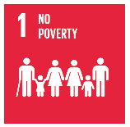

ZERO HUNGER
Sustainable Development Goal
Goal 2: End hunger, achieve food security and improved nutrition and promote sustainable agriculture

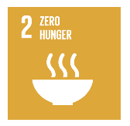

GOOD HEALTH AND WELL-BEING
Sustainable Development Goal
Goal 3: Ensure healthy lives and promote well-being for all at all ages

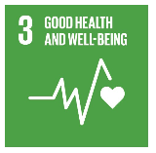

QUALITY EDUCATION
Sustainable Development Goal
Goal 4: Ensure inclusive and quality education for all and promote lifelong learning

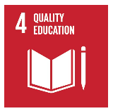

Handout 3.2 Continued
GENDER EQUALITY
Sustainable Development Goal
Goal 5: Achieve gender equality and empower all women and girls

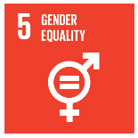

CLEAN WATER AND SANITATION
Sustainable Development Goal
Goal 6: Ensure access to water and sanitation for all

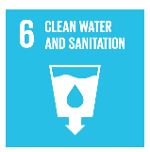

AFORDABLE AND CLEAN ENERGY
Sustainable Development Goal
Goal 7: Ensure access to affordable, reliable, sustainable and modern energy for all

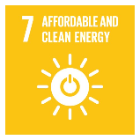

DECENT WORK AND ECONOMIC GROWTH
Sustainable Development Goal
Goal 8: Promote inclusive and sustainable economic growth, employment and decent work for all

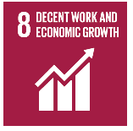

Handout 3.2 continued
INDUSTRY, INNOVATION AND INFRASTRUCTURE
Sustainable Development Goal
Goal 9: Build resilient infrastructure, promote sustainable industrialization and foster innovation

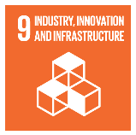

REDUCED INEQUALITIES
Sustainable Development Goal
Goal 10: Reduce inequality within and among countries

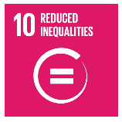

SUSTANABLE CITIES AND COMMUNITIES
Sustainable Development Goal
Goal 11: Make cities inclusive, safe, resilient and sustainable

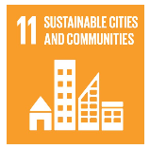

RESPONSIBLE CONSUMPTION AND PRODUCTION
Sustainable Development Goal
Goal 12: Ensure sustainable consumption and production patterns

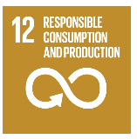

Handout 3.2 continued
CLIMATE ACTION
Sustainable Development Goal
Goal 13: Take urgent action to combat climate change and its impacts

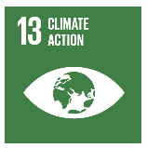

LIFE BELOW WATER
Sustainable Development Goal
Goal 14: Conserve and sustainably use the oceans, seas and marine resources

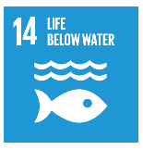

LIFE ON LAND
Sustainable Development Goal
Goal 15: Sustainably manage forests, combat desertification, halt and reverse land degradation, halt biodiversity loss

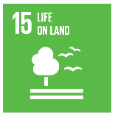

PEACE, JUSTICE AND STRONG INSTITUTIONS
Sustainable Development Goal
Goal 16: Promote just, peaceful and inclusive societies

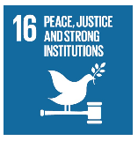

Handout 3.3

Sustainable Development Goals Research

- Go to the Homepage for the Sustainable Development Goals. http://www.un.org/sustainabledevelopment/sustainable-development-goals/#prettyPhoto

- Research the goal on the card you were given. For example, Goal 1: No poverty. End poverty in all its forms everywhere.
  - Read the facts and figures.
  - Read the targets.
  - Check out the links.
  - Scroll down and read two articles on Related News.
  - Scroll further and watch two of the related videos.
  - Summarize your thoughts on another page.
  - Lists words or statements of importance and statistics that would be important to share with your classmates.

- Go to Gapminder – gapminder.org.
  - Watch one of the introductory TEDtalks scrolling across the home screen.
    - Recommended: Dollar Street: http://www.gapminder.org/dollar-street/ - Learn about photos as data and income versus culture.
  - In the data search box find graphs related to your topic. View at least four. Summarize your thoughts on another page.

- Use www.piktochart.com or another site to create an infographic to share with your classmates on your Sustainable Development Goal. Be sure to include your names as creators.

Handout 3.4

Infographic Rubric:
SDG: Creators:

 | Excellent  (1 – 5 high) | Satisfactory  (1 – 5 high) | Needs Work  (1 – 5 high)
Appearance
(color, lines, visual effects)
Content
(conveys important info, well organized)
Creativity
(shares important ideas in an interesting way)
 |  | Total

Infographic Rubric:
SDG: Creators:

 | Excellent  (1 – 5 high) | Satisfactory  (1 – 5 high) | Needs Work  (1 – 5 high)
Appearance
(color, lines, visual effects)
Content
(conveys important info, well organized)
Creativity
(shares important ideas in an interesting way)
 |  | Total

